Ben Sottile

Big Data Using Beer Master

Note: Used old foreign key beermaster data set so it would output less data and be quicker to test Each table has two rows

Query used

select drinkers.first_name, drinkers.last_name, drinkers.email, frequents.id_frequents, bar.bar_name, bar.address,sells.price,sells.id_Sells,beer.beer_name,beer.manf,beer.container,beer.top,likes.likes_id,likes.drinker from drinkers

left join frequents

on drinkers.id_drinkers = frequents.drinker

left join bar

on frequents.bar = `bar_ id`

left join sells

on `bar_ id`= sells.bar

left join beer

on beer_being_sold = beer_id

left join likes

on beer_id = beer_liked;

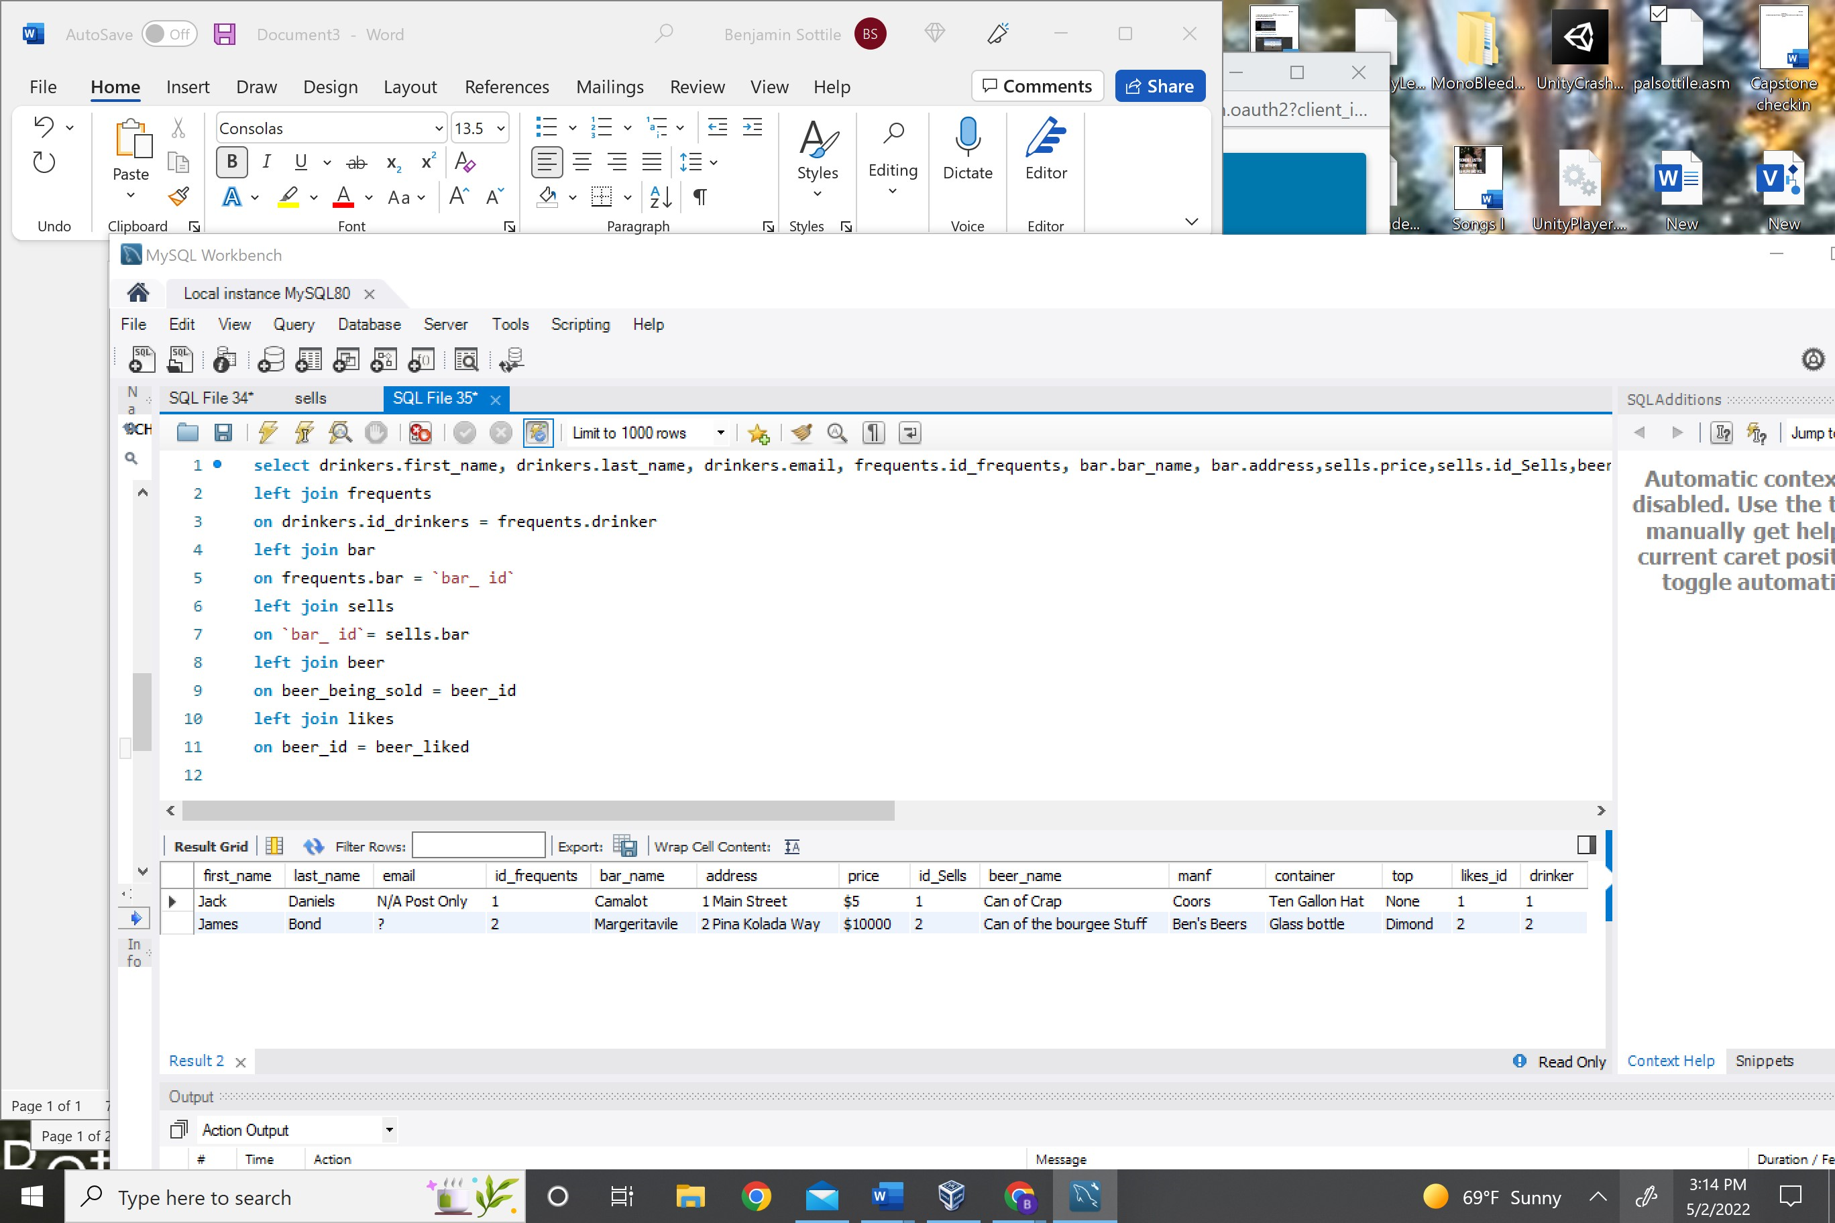

I then exported it as a json

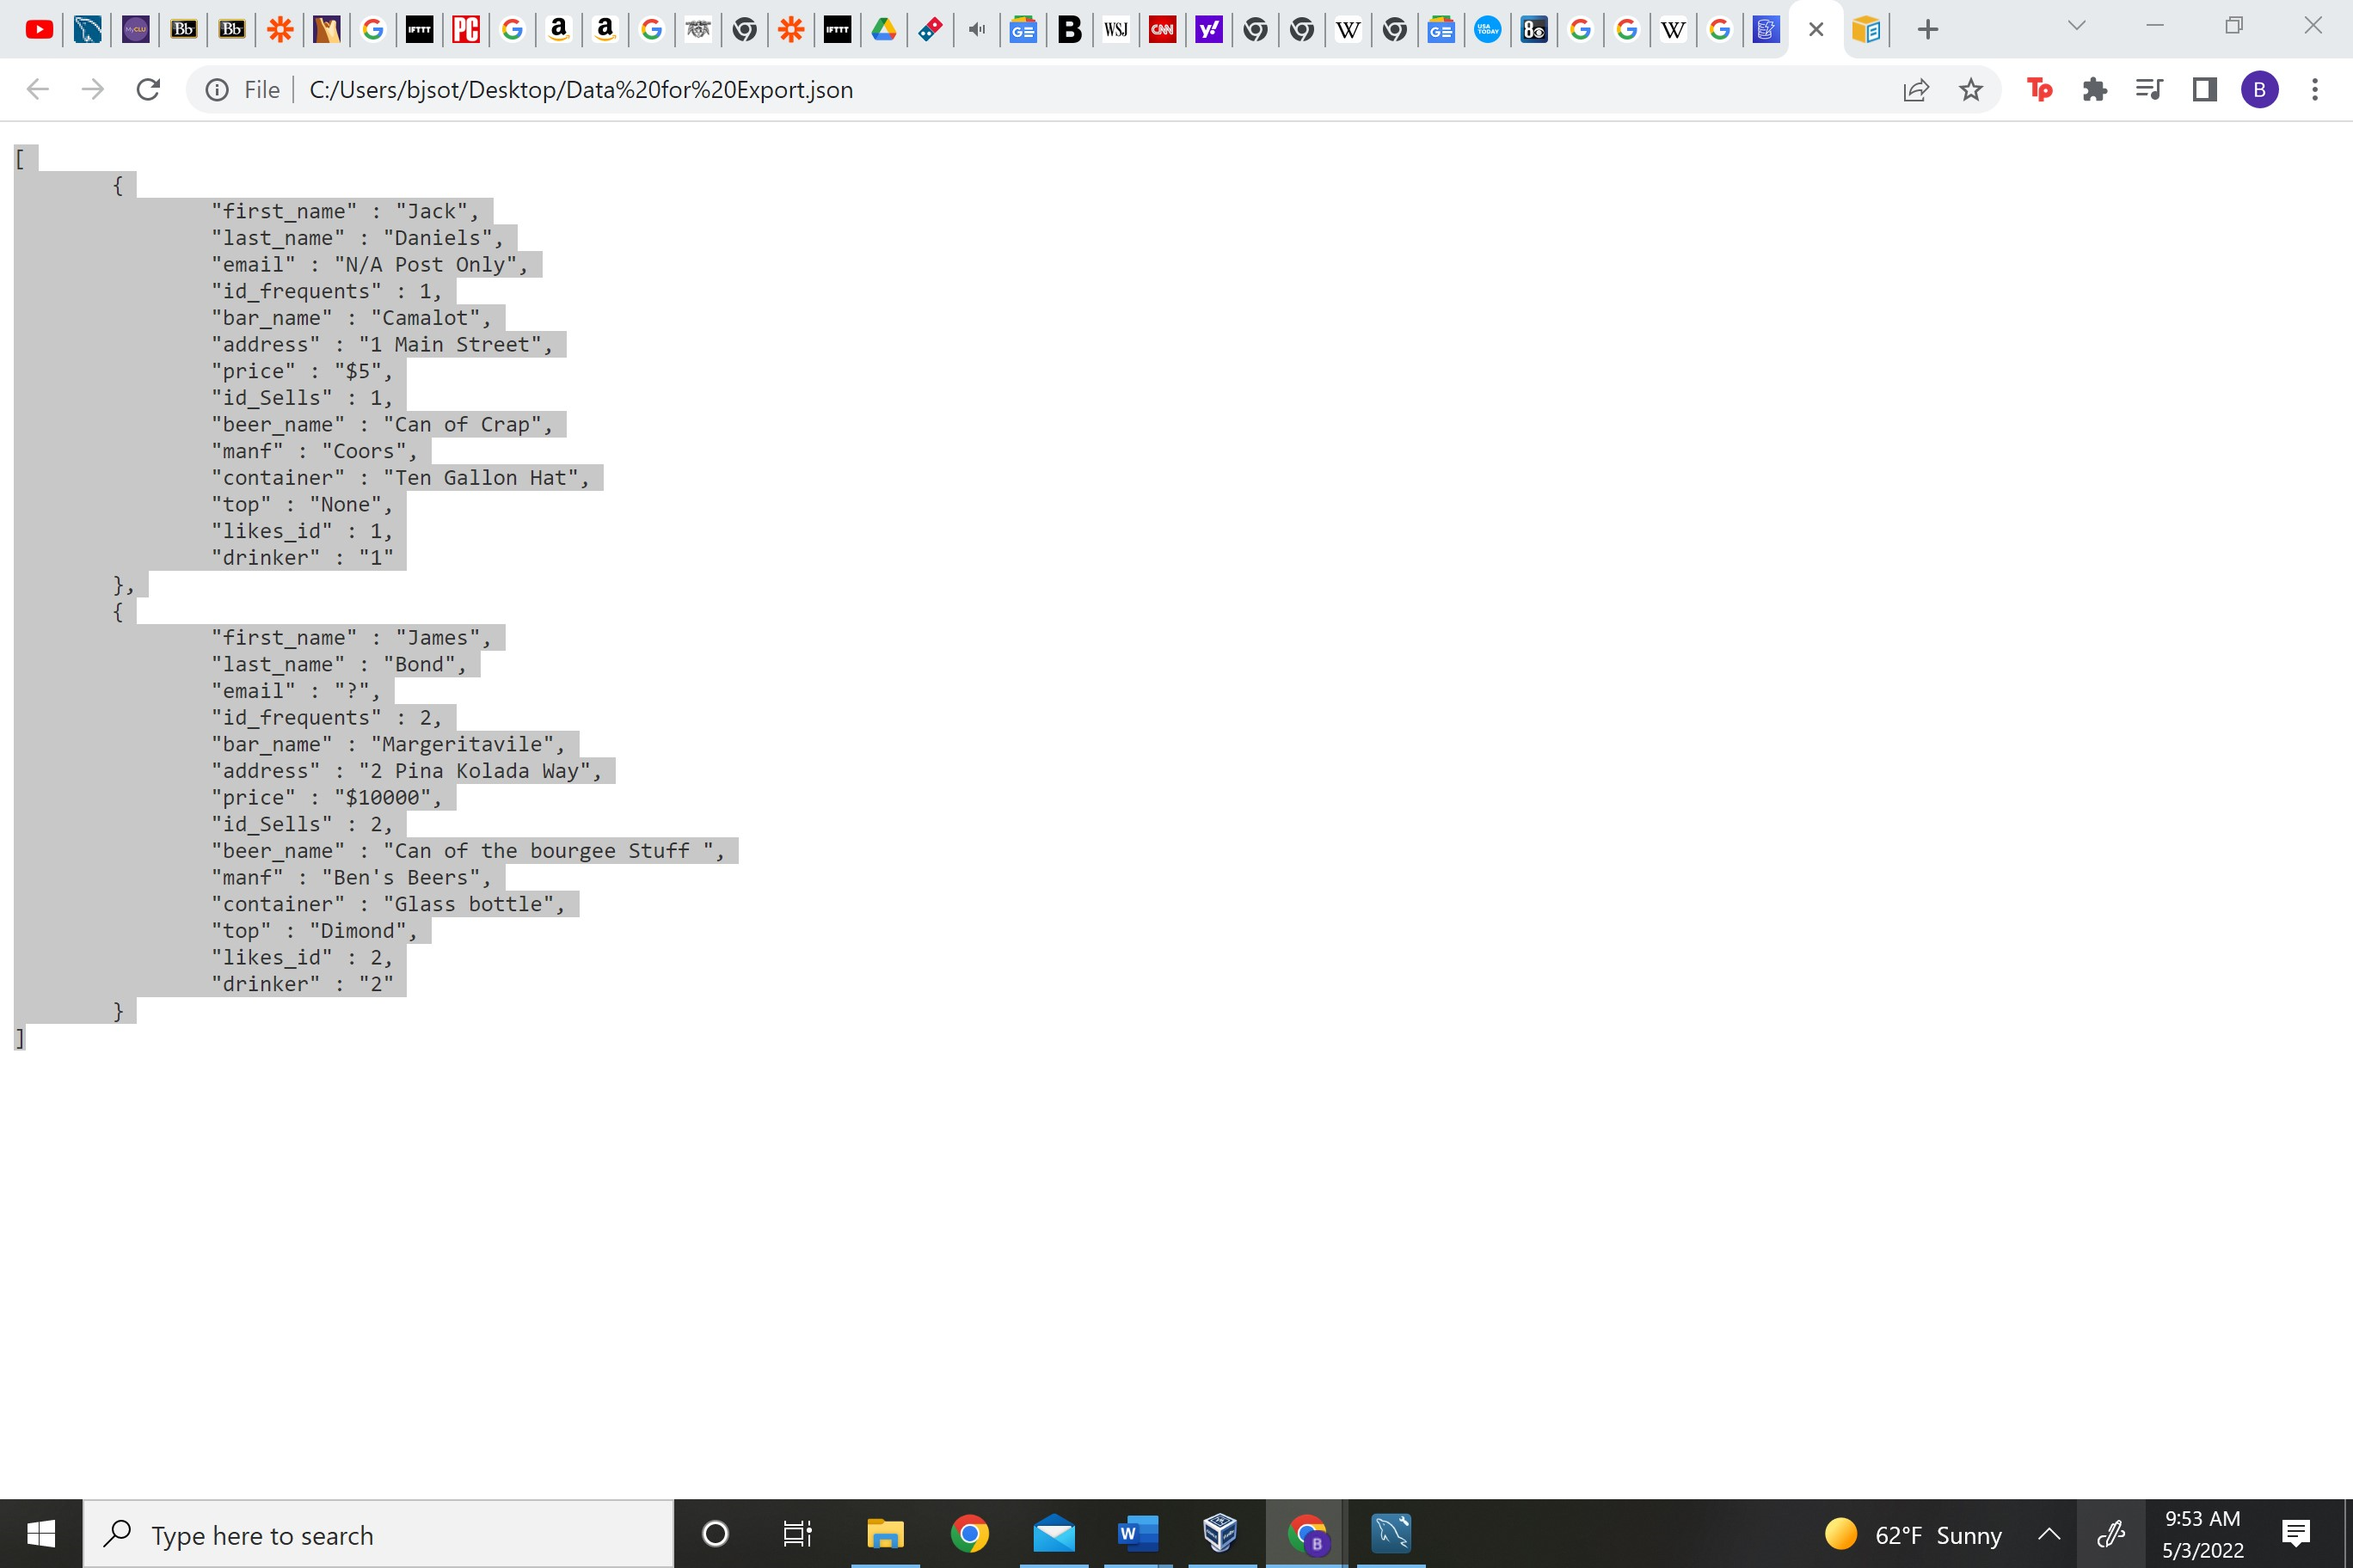

<https://www.youtube.com/watch?v=X4ZkZEfVFJE&t=0s>

used tutorial here to add data with lamda function.

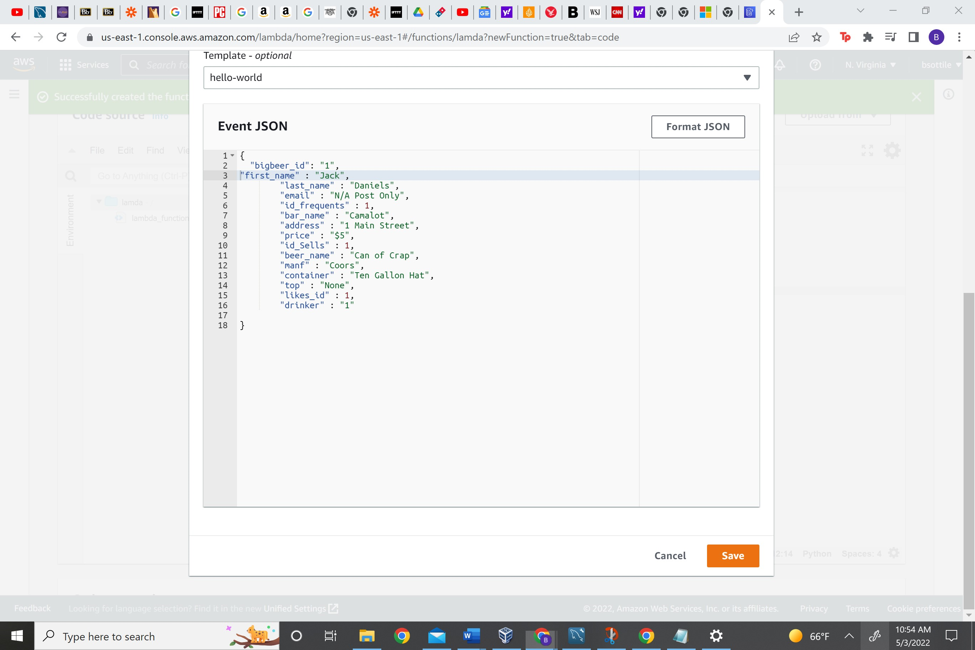

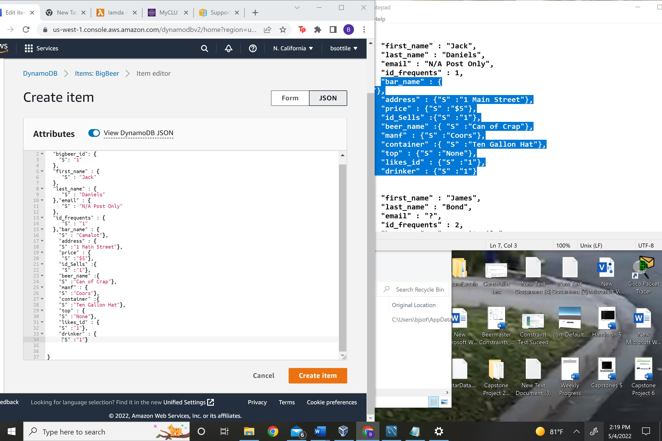



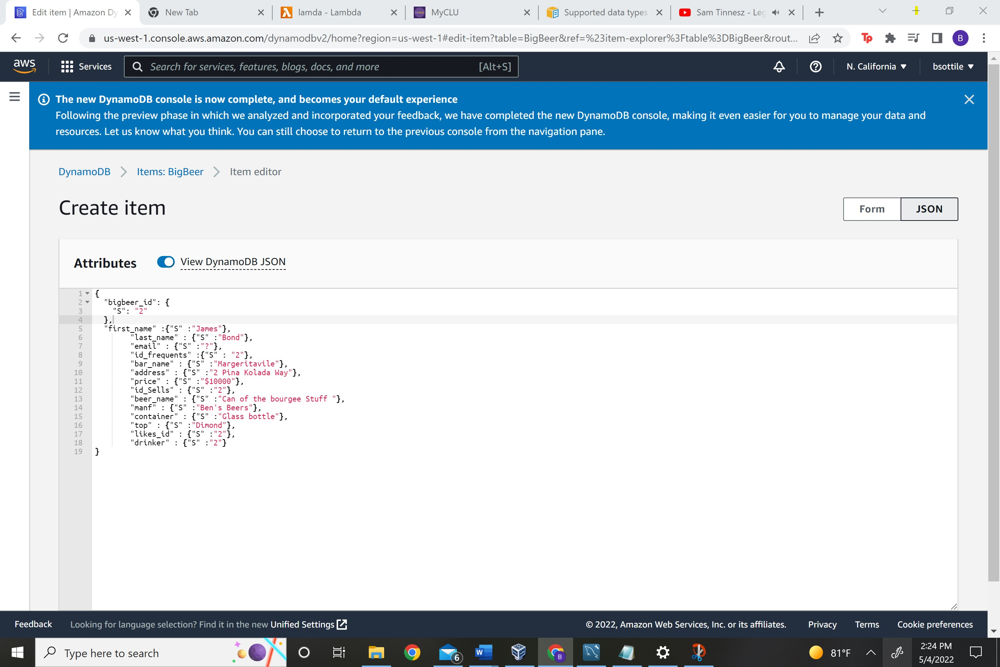

Query rows: 2

